Rishi Sunak MP,
Parliamentary Under Secretary of State
(Minister for Local Government)
Ministry of Housing Communities and Local Government,
Marsham Street,
London

17 June 2019

Dear Mr Sunak,

I am writing to you on behalf of the Resources Board of the LGA to raise concerns about the impact of the decision by Ernst and Young to delay the audit of accounts for local authorities covered by it in the East of England / East Midlands. We understand that Ernst and Young say this is due to an unavoidable shortage of suitably qualified senior auditors which has arisen in this part of the country.

In 2014 in our response to the consultation on the Local Audit regulations, which included the new tighter timetable for the publication of annual accounts, we raised concerns that the limited supply of auditors and overlap with other bodies timetables (particularly NHS) could result in the systems being vulnerable to problems like those now occurring. While councils have shown that they are capable of meeting the earlier July deadline, clearly this is not the case for the system as a whole and we would therefore ask that the deadline is reviewed and pushed back to 30 September for future years.

Ernst and Young’s decision means the local authorities affected won’t be able to publish their accounts by the 31 July deadline with an audit certificate, as would normally be expected for the 2018/19 accounts. This affects sixteen councils, as well the two Police and Crime commissioners and the single Combined Fire Authority.

Clearly this is not a satisfactory position and all those affected would like steps to be taken to avoid this situation. However, given the timing, it is likely that the only practical step to avoid the situation would be for Ernst and Young to reverse the action that they are taking. Since that is unlikely, it is important that the problems of those local authorities affected are minimised and that they do not suffer additional consequences as a result of something that is beyond their control. Councils should not be criticised for failing meeting a deadline through no fault of their own.

For example, the LGA’s Resources Board thought that the affected local authorities should be excluded from any reporting of performance metrics where the failure of their accounts being audited would show them in a bad light, for example reporting of councils that have / have not published their accounts on time. The Resources Board was also concerned that the affected councils do not incur additional costs, particularly audit costs, as a result.

We are liaising with PSAA who are having continuing discussions with Ernst and Young and the Board wanted to make sure that you as Local Government Minister were also aware of the concerns of our members.

Yours faithfully

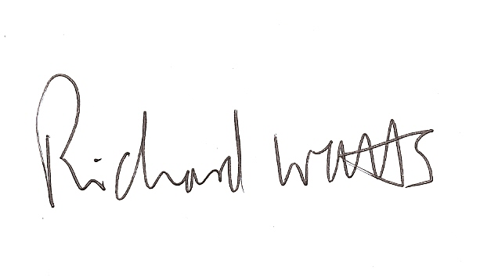

Cllr Richard Watts,

Chair Resources Board

